Supporting information (SI)

Appendix S1: Selection of arthropods for C:N analysis

We selected two broad functional groups to evaluate the differences in % nitrogen among native and non-native plants. Spiders (Araneae) were selected as indicators of the %N content of the third trophic level as arthropod predators. Our other function group were insect herbivores. We selected insect herbivores from families that were most likely to feed on plant foliage, particularly the foliate of woody plants included in our experiment. These represent the nutritional content of insect prey primarily available to bird and the numerical majority of arthropods collected. Insect herbivore families selected included: All families of Lepidoptera collected (primarily Geometridae and the superfamily Noctuoidea), Hemipteran families including Tingidae, Miridae, Coreidae, Pentatomidae, Acanthosomatidae, and Thyreocoridae. We included sawfly families Cimbicidae and Tenthrediniadae. The only beetle families selected were those likely to feed on foliage as adults or larvae, including Brentidae, Chrysomelidae, Cleridae, Curculinidae (only the subfamily Entiminae) and Melolonthinae.

Figure. S1. Average abundance of aquatic insects (# per bagged branches) among ten sampled host-plant species. Bar height indicates estimated mean from GLMM, and error bars indicate 95% confidence intervals. Bars with non-overlapping confidence intervals are significantly different. Bars ranked by estimated means.

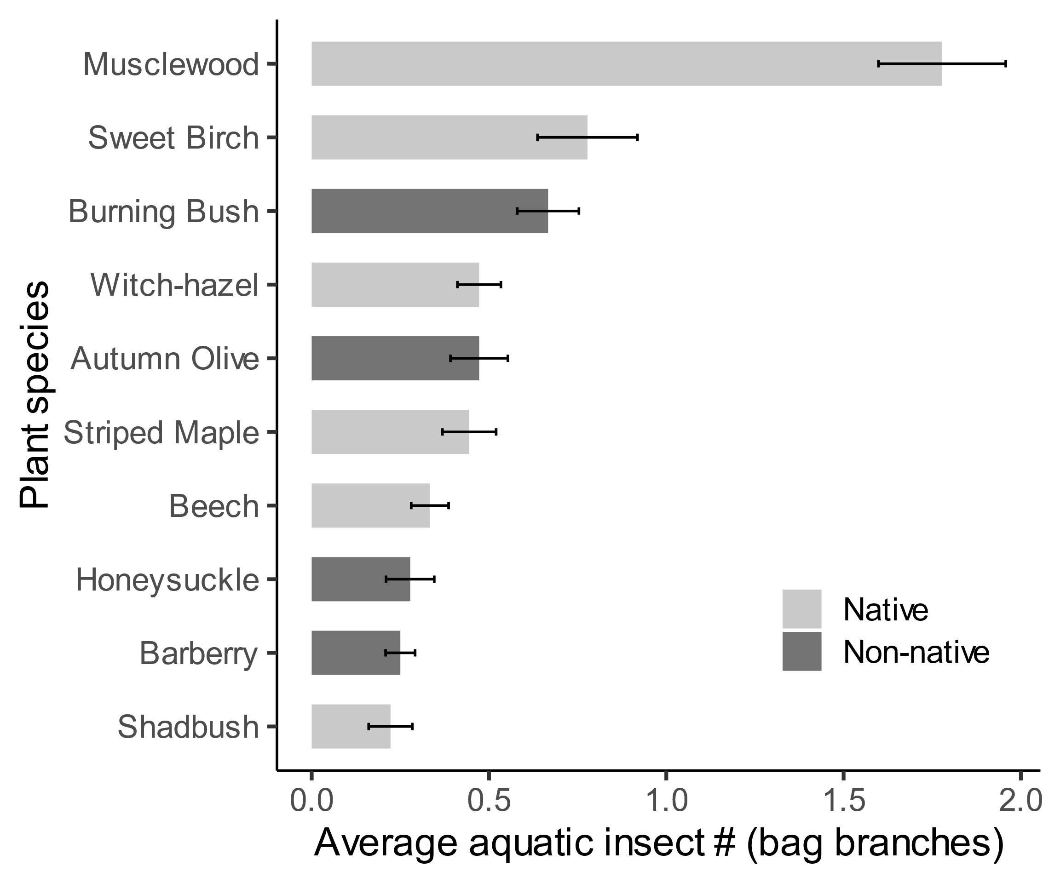

Fig. S2. Average abundance of lepidoptera (# of caterpillars per bagged branches) among ten sampled host-plant species. Bar height indicates estimated mean from GLMM, and error bars indicate 95% confidence intervals. Bars with non-overlapping confidence intervals are significantly different. Bars ranked by estimated means.

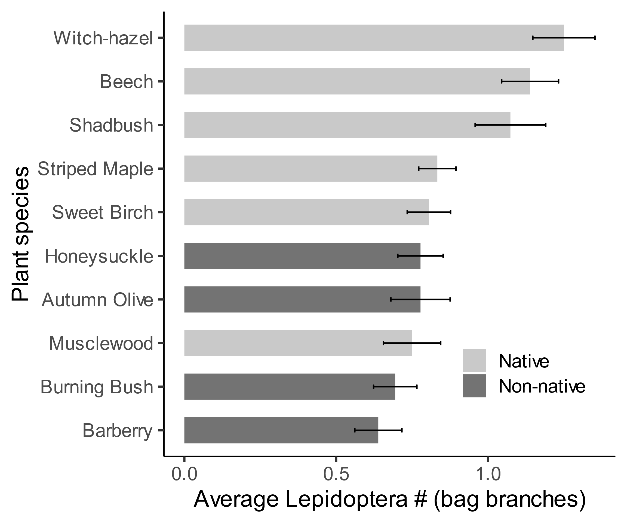

Fig. S3. Average abundance of spiders (# of spiders per bagged branch) among ten sampled-host plant species. Bar height indicates estimated mean from GLMM, and error bars indicate 95% confidence intervals. Bars with non-overlapping confidence intervals are significantly different. Bars ranked by estimated means.

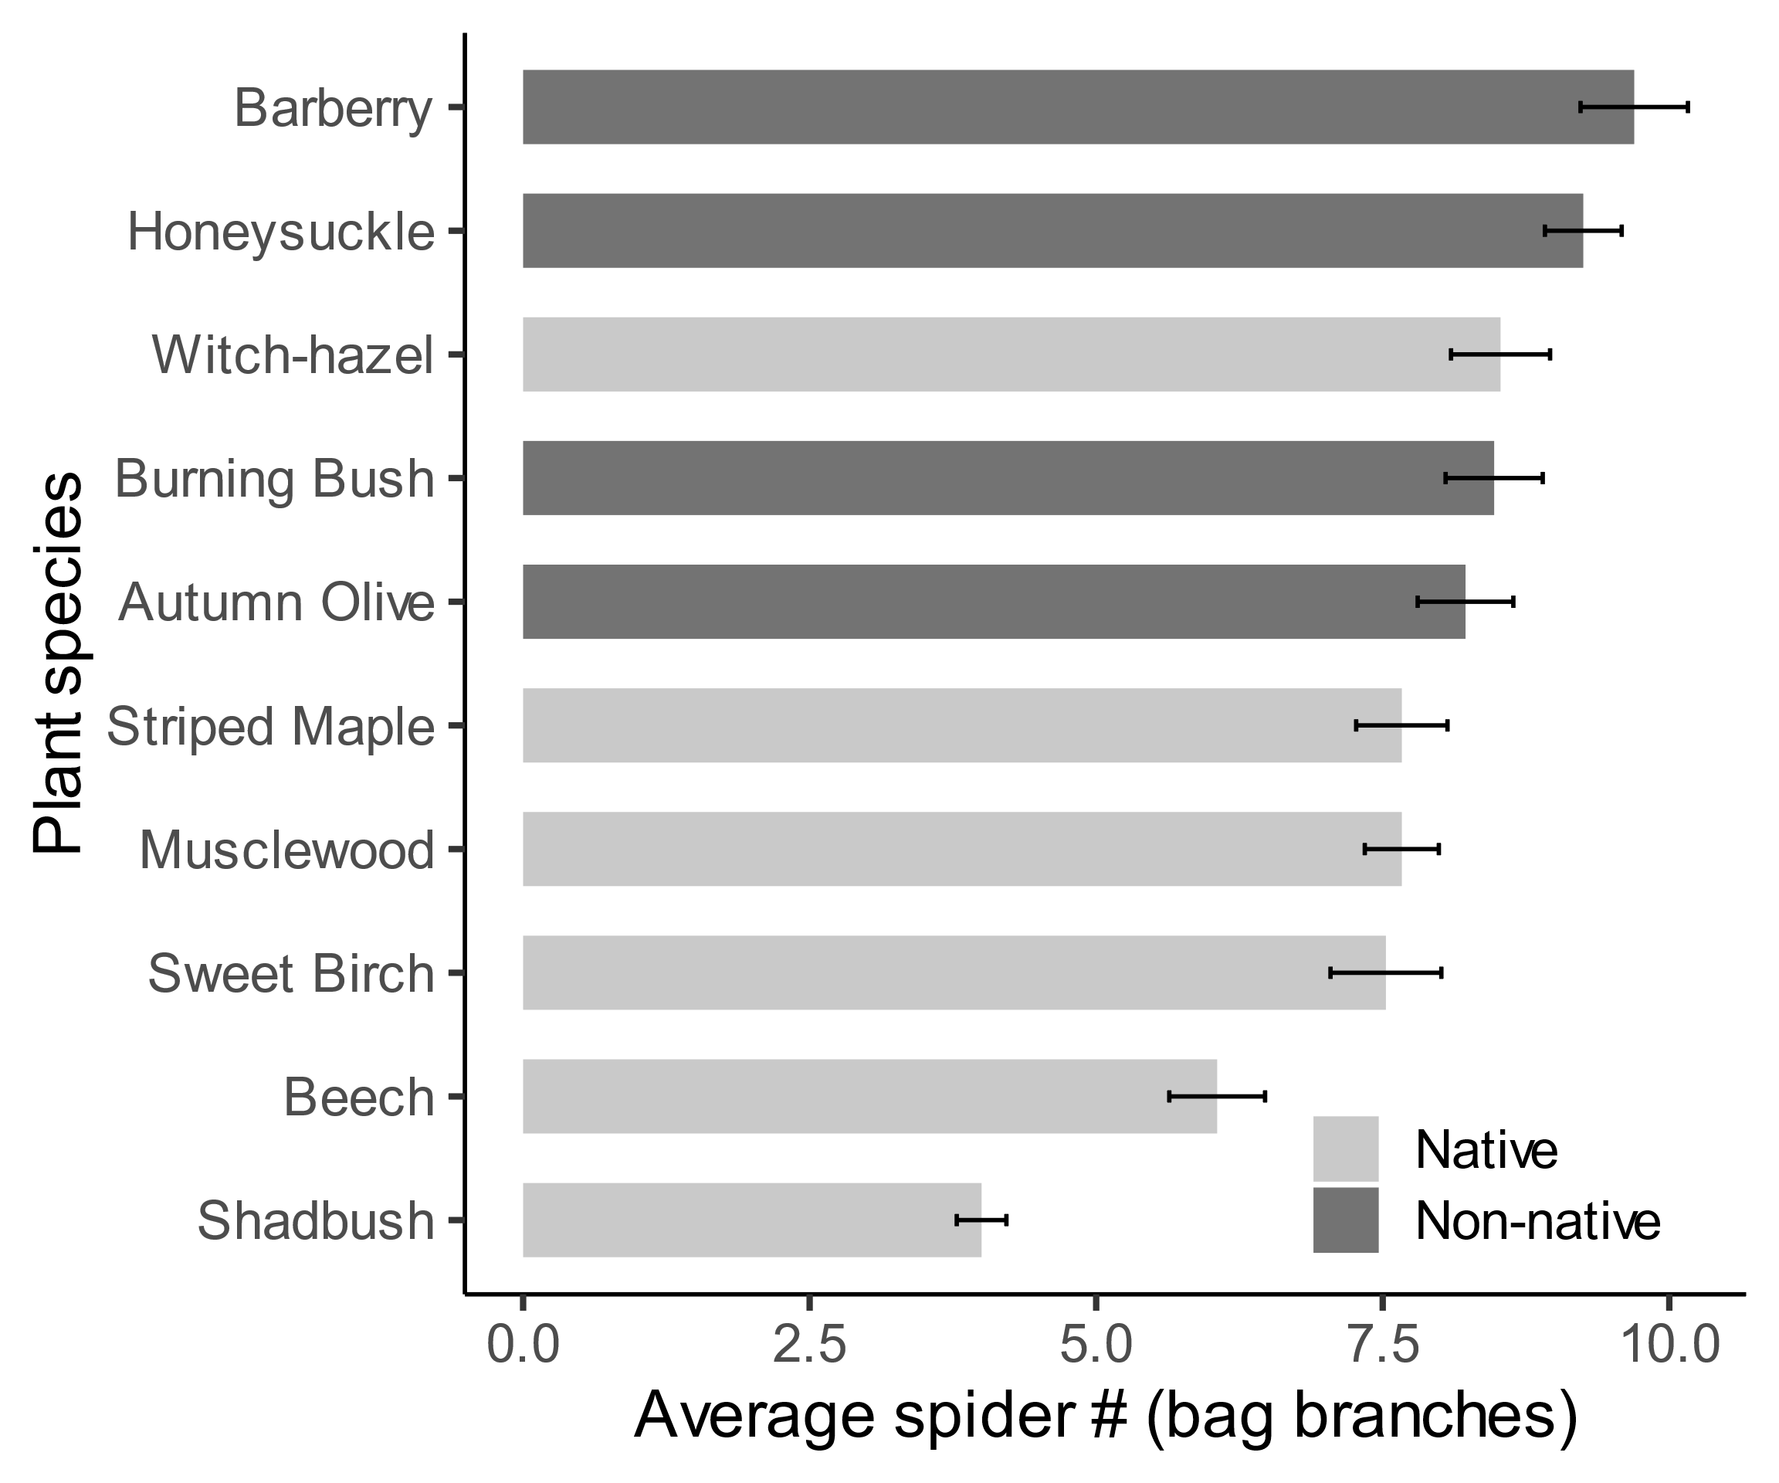

Appendix S2: Supporting analyses

In support of our results, we also tested for differences among all plant species (Fig. S4, S5, S7, S8), and for the effects of bird-bag exclusion on arthropod abundance (Fig. S6). Abbreviations are as follows: BE is American beech (Fagus grandifolia), MW is musclewood (*Carpinus caroliniana)*, SH is shadbush (*Amelanchier canadensis*), SM is striped maple (*Acer pennsylvanicum*), SB is sweet birch (*Betula lenta*), WH is witch-hazel (*Hamamelis virginiana*), AO is autumn olive (*Eleagnus umbellata*), BA is Japanese barberry (*Berberis thunbergii*), BU is burning bush (*Eunonymous alatus*) and HS is Morrow’s honeysuckle (*Lonicera morowii*).

Fig. S4. Arthropod biomass (total grams per branch) among the ten sampled host-plant species. Biomass is reported as total wet mass collected from branches. Mean ± SEM is plotted. Circles are native species, triangles are invasive species, see Appendix S2 overview for description of abbreviations.

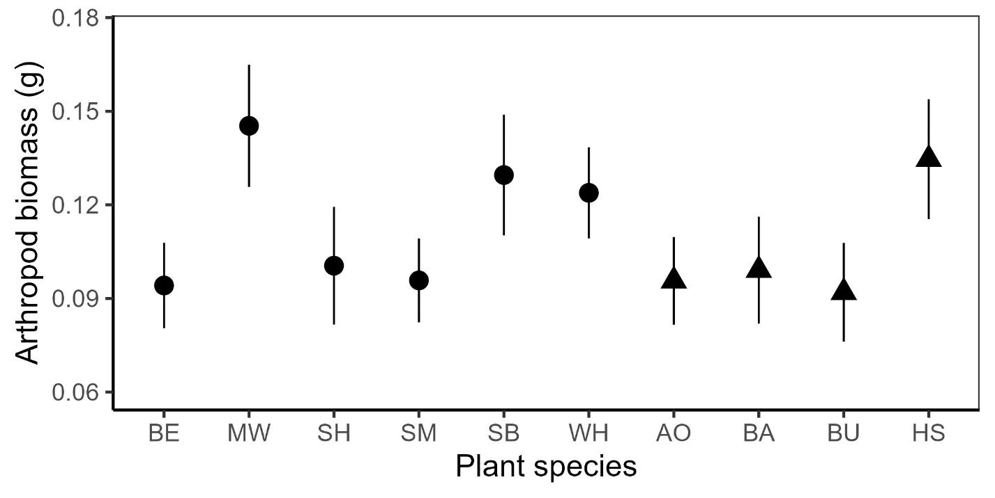

Fig. S5. Effect size of bird exclusion treatment among ten sampled host-plant species. Bird exclusion effect size reported as Log-Response Ratios (LRR), in which positive values > 0 indicate a significant reduction in arthropod abundance in response to bird predation. Mean ± SEM is plotted. Circles are native species, triangles are invasive species, see Appendix S2 overview for description of abbreviations.

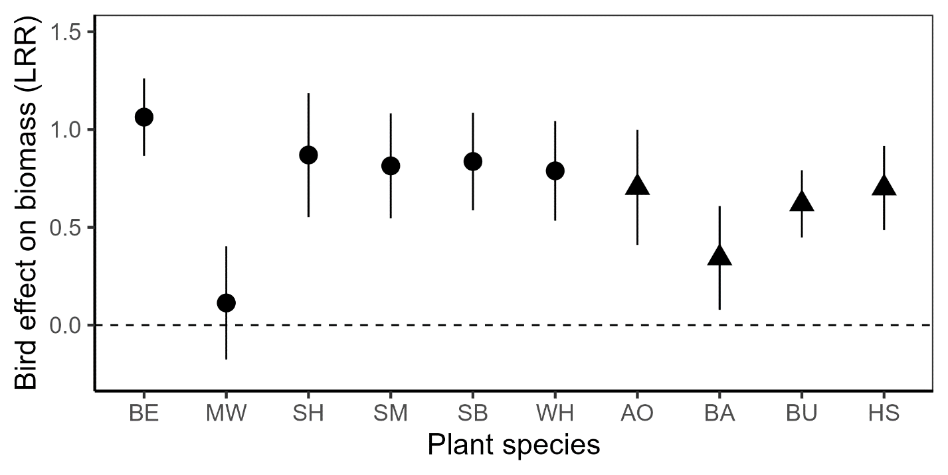

Fig S6. Effects of bird-bag exclusion treatment under the context of native versus non-native host-plant groups. Points with lines connecting them are significantly different from each other if they have different letters (Scheffe’s test for pairwise comparisons were completed for each of the eight sub-panels). Each panel indicates the response of a single taxonomic group and changes in Mean ± SEM abundance: S6a. Araneae (true spiders), S6b. Hemiptera (herbivorous true bug families), S6c. Lepidoptera (caterpillars), and S6d. Orthoptera (tree crickets and katydids).

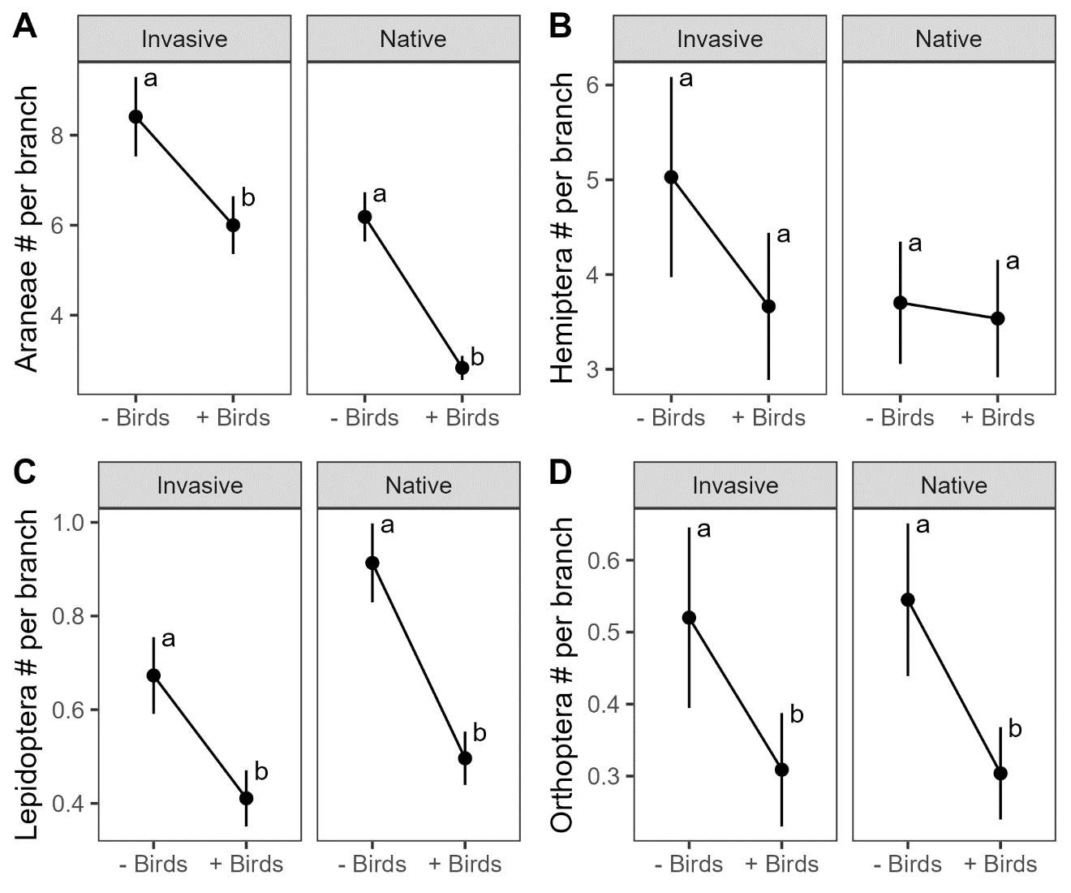

Fig S7. Total % nitrogen for insect herbivores among ten host-plant species. Nitrogen content is measured as the total molecular mass of elemental nitrogen relative to total mass of a single sample from an experimental host-plant branch. Only bagged branches were included in analysis, mean ± SEM is plotted. Circles are native species, triangles are invasive species, see Appendix S2 overview for description of abbreviations.

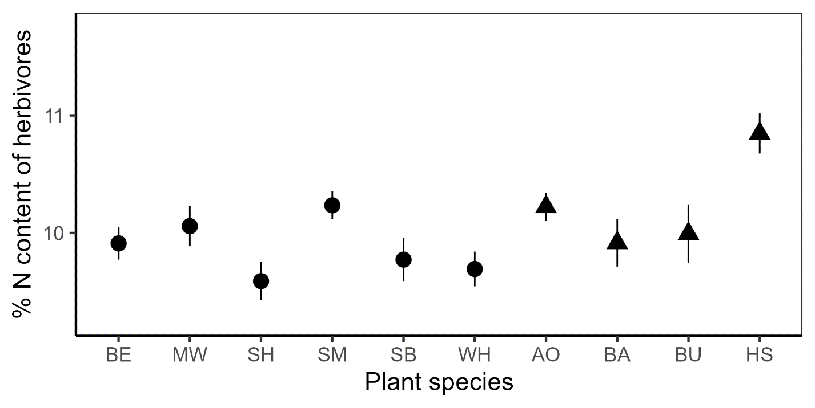

Fig. S8. Total % nitrogen for true spiders among ten host-plant species. Nitrogen content is measured as the total molecular mass of elemental nitrogen relative to total mass of a single sample from an experimental host-plant branch. Only bagged branches were included in analysis, mean ± SEM is plotted. Circles are native species, triangles are invasive species, see Appendix S2 overview for description of abbreviations.

